

CSA15 – CLOUD COMPUTING AND BIG DATA ANALYTICS

ASSIGNMENT 1 – CO1
Design, Analyse and Validate a Cloud-Based Solution for Migrating a Legacy University Management System
CO1: Apply cloud computing technologies including hardware–software evolution, virtualization, web services, and service models to develop cloud-based solutions.
Field | Details | Field | Details
Student Name | RASHMITHA. S | Register Number | 192525034
Department / Section | B. TECH AIML | Academic Year / Semester | II YEAR
Faculty Name | Dr. R. LATHA | Nature of Assignment | Individual
Duration | 1 Week | Total Marks | 50
Submission Date | 31/10/2026 | Evaluation Date
MARK SHEET (Rubric-based evaluation)
Task | Title | Max | Awarded | Evidence / evaluation focus
1 | Introduce Cloud Computing | 3 |  | Definition; characteristics; deployment models; scenario mapping
2 | Trace Evolution and Hardware Evolution | 3 |  | Timeline; hardware evolution; relevance to university
3 | Analyse Internet Software Evolution | 3 |  | Web/software evolution; SOA; APIs; scenario relevance
4 | Apply Server Virtualization | 5 |  | Hypervisor types; VM/container comparison; consolidation; limitations
5 | Apply Web Services | 4 |  | SOA and SOAP/REST; three university APIs; request/response examples
6 | Analyse IaaS, PaaS and SaaS | 5 |  | Responsibility layers; five-application mapping; comparison; providers
7 | Examine XaaS | 3 |  | Four or more variants; two justified choices; provider risks
8 | Design Cloud Solution | 5 |  | Labelled diagram;

 | Architecture |  |  | deployment/service models; scaling;  security; DR
9 | Hands-on Implementation and Documentation | 4 |  | Running VM/container; PaaS/SaaS; tests; actual screenshots
10 | Evaluate and Recommend Final Solution | 7 |  | Three-way comparison; 3-year costs; risks; phased roadmap
11 | Day-4 Design Challenge | 8 |  | Impact; evaluation; adaptation; evidence-based defence
 | TOTAL | 50 |  | Percentage :

EVIDENCE VERIFICATION CHECKLIST

Tasks | Evidence expected | Status (✓  / P / ✗ ) | Evaluator note
1–3 | Conceptual explanations, comparisons and relevant illustrations | ✓ | Explanations and relevant scenario mapping documented
4 | Virtualization calculations with stated assumptions and peak-load caution | ✓ | Calculations present; practical capacity validation recommended
5–7 | API examples, service responsibility table and justified XaaS choices | ✓ | Required conceptual evidence documented
8 | Labelled architecture diagram, caption below figure and component justification | ✓ | Architecture documented; sizing assumptions need testing
9 | Actual code, environment details, execution logs, API outputs and screenshots | P | Procedures provided; actual execution evidence not established
10 | Cost assumptions, 3-year totals, risk controls and migration roadmap | ✓ | Estimates and rationale documented
11 | Day-4 changes, 10× load strategy, 99.9% target and 40-college isolation | ✓ | Design analysis documented; practical validation pending

IMPLEMENTATION EVIDENCE CHAIN

Evidence item | Status | Observation
Source code | ✓ | Flask REST API and Dockerfile provided in the proposed implementation
Virtualization | P | Docker container configuration documented; running-container evidence required
PaaS or SaaS | P | Managed web-service deployment procedure described; live deployment not verified
Functional test | P | Expected HTTP 200 response and JSON output documented; actual output required

Failure case | P | HTTP 404 test case documented; actual execution record required
Screenshots | P | Screenshot requirements identified; authentic screenshots need verification
Reproducibility | ✓ | Build commands, run commands, endpoints and expected results specified

OVERALL REMARKS

Student Signature | Faculty Signature | Program Director

MANDATORY SUBMISSION EVIDENCE CHECK
✓ = Present in documented answer; P = Partly present; ✗ = Missing / not satisfied

Task | Evidence expected | Status | Evaluator note
1 | Cloud definition, characteristics, deployment models and scenario mapping | ✓ | All conceptual requirements covered
2 | Evolution timeline, hardware  development and university relevance | ✓ | Well explained with relevant examples
3 | Internet software evolution, SOA and APIs | ✓ | Clear explanation and scenario relevance
4 | Hypervisors, VM/container comparison and consolidation calculations | ✓ | Calculations included; peak-load limitations discussed
5 | SOAP/REST comparison and three university APIs | ✓ | API methods and request/response examples documented
6 | IaaS/PaaS/SaaS responsibility layers and application mapping | ✓ | All five applications categorized with justification
7 | XaaS variants and two justified selections | ✓ | Six variants explained; DBaaS and DRaaS recommended
8 | Labelled architecture, scaling, security and disaster recovery | ✓ | Design and component justifications documented
9 | Working container, PaaS/SaaS deployment, actual tests and screenshots | P | Code and procedures provided; actual execution evidence requires verification
10 | Three-year cost comparison, risks and migration roadmap | ✓ | Cost assumptions, calculations and recommendations included
11 | Impact analysis, 10× load, 99.9% availability and tenant isolation | ✓ | Changed requirements evaluated; load-test evidence recommended

IMPLEMENTATION EVIDENCE CHAIN

Evidence item | Status | Observation
Source code | ✓ | Python Flask REST API and Dockerfile documented
Virtualization | P | Docker build and run procedures provided; execution screenshot required
PaaS or SaaS | P | Cloud deployment steps described; actual deployment confirmation required
Functional test | P | HTTP 200 and expected JSON response documented; actual

 |  | test output required
Failure case | P | HTTP 404 test case included; execution evidence required
Screenshots | P | Required screenshots identified but authenticity and completeness not verified
Reproducibility | ✓ | Installation, configuration, commands and testing steps documented
Interpretation | ✓ | Technical outcomes and implementation limitations explained
Code and report consistency | ✓ | Proposed API, Docker configuration and testing procedure are aligned

SUBMISSION CHECKLIST (Not Separately Marked)

Requirement | Status
All 11 tasks answered | ☒ Yes ☐ Partly ☐ No
Cloud concepts and comparisons explained | ☒ Yes ☐ Partly ☐ No
Virtualization calculations included | ☒ Yes ☐ Partly ☐ No
API examples and service models explained | ☒ Yes ☐ Partly ☐ No
Cloud architecture diagram included | ☒ Yes ☐ Partly ☐ No
Implementation and testing evidence provided | - Yes ☒ Partly ☐ No
Three-year cost analysis and roadmap included | ☒ Yes ☐ Partly ☐ No
Day-4 design challenge completed | ☒ Yes ☐ Partly ☐ No
Figures and screenshots included | - Yes ☒ Partly ☐ No
Table and figure numbering correct | - Yes ☒ Partly ☐ No
Viva recommended | ☒ Yes ☐ No

CSA15 – Cloud Computing and Big Data Analytics

ASSIGNMENT 1
CO1: Apply cloud computing technologies including hardware–software evolution, virtualization, web services, and service models to develop cloud-based solutions.

Assignment Title: Design, Analyse and Validate a Cloud-Based Solution for Migrating a Legacy University Management System (Total Marks – 50)

Duration: 1 week

Scenario – Smart Campus Cloud Migration
A multi-campus university currently runs its Student Information System, Learning Management System, Library System, Exam Portal and Email on ageing physical servers in a single on-premise data centre. Each application has its own dedicated server, which stays idle for most of the year but fails to cope during admissions, result publication and online-exam weeks.
The university's current environment is:
- 12 physical servers, average CPU utilisation of about 15%, with peaks above 95% during admissions and exams
- Approximately 25,000 students and 2,000 staff across 4 campuses
- Applications built as large monolithic programs, with no public interfaces for mobile apps or partner colleges
- High capital expenditure, slow procurement (6–8 weeks per server) and no disaster recovery site
As a cloud consultant, you must study how computing evolved to the cloud model, and then design a cloud-based solution that uses virtualization, web services and an appropriate mix of service models (IaaS, PaaS, SaaS and XaaS) for the university. All recommendations must be justified in terms of cost, scalability, availability and manageability.

Design Challenge:
On Day 4, the university announces that it will launch a mobile app and open student-record and fee-payment services to 40 affiliated colleges. Expected load is 10 times the current peak, with a requirement of 99.9% availability and a limited operating budget. Re-evaluate your original design and decide whether it should be retained, modified or redesigned.

TASK 1 – Introduce Cloud Computing and Map It to the Scenario (3 Marks)

Design and Propose cloud computing model for the context of the university's problems.
- Definition of cloud computing and the five essential characteristics (on-demand self-service, broad network access, resource pooling, rapid elasticity, measured service)
- Deployment models (public, private, hybrid, community) and which one suits the university
- Three problems of the current on-premise setup and how each cloud characteristic addresses them
- Benefits and limitations of cloud adoption for the university

Evidence Expected
A clear explanation of cloud characteristics and deployment models, mapped to the university's actual problems.

TASK 2 – Trace the Evolution and Hardware Evolution (3 Marks)
Trace how computing infrastructure evolved to make cloud computing possible.
- A timeline from mainframes, minicomputers and PCs, to client–server, clusters, grid computing, utility computing and cloud
- Hardware evolution: multi-core processors, commodity servers, high-capacity storage, high-speed networking and data centres
- How each stage solved a limitation of the previous one
- Which stage the university's current system corresponds to, with reasons

Evidence Expected
A labelled timeline or diagram, with a justified explanation of how hardware advances enabled the cloud.

TASK 3 – Analyse Internet Software Evolution (3 Marks)
Explain how internet software evolved and why it supports cloud services.
- Evolution from static web pages to dynamic web, Web 2.0, SOA, mashups and cloud-hosted applications
- Role of browsers, HTTP, AJAX and APIs in delivering software over the internet
- Comparison between desktop software, client–server software and web-delivered software
- How this evolution affects the design of the university's applications

Evidence Expected
A comparative explanation of software evolution stages, linked to the university's application design.

TASK 4 – Apply Server Virtualization (5 Marks)
Apply server virtualization to consolidate the university's 12 physical servers.
- Explain how a hypervisor works, and distinguish Type-1 and Type-2 hypervisors, with examples
- Compare full virtualization, para-virtualization, OS-level virtualization (containers) and hardware-assisted virtualization
- Propose which applications should run as virtual machines and which as containers, with reasons
- Calculate the consolidation: with an average utilisation of 15% per server and a target host utilisation of 70%, estimate how many physical hosts are needed (show your assumptions and working)
- Discuss live migration, snapshots and resource over-commitment as benefits, and the risks of virtualization (noisy neighbour, hypervisor failure, security isolation)

Show your calculation. A final number without working will not receive full credit.

Evidence Expected
A justified virtualization plan with a worked consolidation calculation and discussion of benefits and risks.

TASK 5 – Apply Web Services (4 Marks)
Analyse web services to expose the university's functions to other systems.
- Overview of web services and their role in cloud and SOA
- Compare SOAP, WSDL, UDDI and RESTful services (HTTP methods, JSON/XML)
- Identify at least three university functions to expose as web services (for example, result lookup, fee payment, library search) and define the endpoint, method and sample request/response for each
- Justify whether SOAP or REST is more suitable for each function

Evidence Expected

A defined set of web services with sample request/response formats and a justified choice of SOAP or REST

TASK 6 – Analyse the Service Models: IaaS, PaaS and SaaS (5 Marks)
Analyse which service model fits each university application.
- Define IaaS, PaaS and SaaS, and show who manages which layer (hardware to application) in each model
- Categorise the five university applications (SIS, LMS, Library, Exam Portal, Email) into IaaS, PaaS or SaaS, with reasons
- Compare the models on control, cost, scalability, maintenance effort and vendor lock-in
- Give one real provider example for each model
Present your categorisation in a table, but explain the reasoning behind each
decision. A table alone is not sufficient.

Evidence Expected
A reasoned mapping of applications to service models, supported by a layer-wise responsibility comparison.

TASK 7 – Examine XaaS (3 Marks)
Examine the broader XaaS (Anything-as-a-Service) concept for the university.
- Explain XaaS and describe at least four variants (for example DaaS, BaaS/MBaaS, FaaS, DBaaS, Security-as-a-Service, Disaster-Recovery-as-a-Service)
- Select two XaaS offerings that would benefit the university, and justify them
- Discuss the risks of over-reliance on multiple 'as-a-Service' providers

Evidence Expected
An analysis of XaaS variants, with justified selection of two offerings for the university.

TASK 8 – Design the Cloud Solution Architecture (5 Marks)
Bloom's Level: Level 6 – Create | Action verbs: Design, Construct, Propose
Create a complete cloud architecture for the university by combining virtualization, web services and service models.
- An architecture diagram showing users, load balancer, web/application tier, database tier, storage, API layer and DR region

- The deployment model and the service model chosen for each component
- How elasticity (auto-scaling) will handle admissions and exam peaks
- Basic security and availability measures (access control, encryption, backup, multi-zone deployment)

Evidence Expected
A labelled architecture diagram with written justification for each component and design decision.

TASK 9 – Hands-on Implementation and Documentation (4 Marks) Implement a small proof-of-concept of your design using a free-tier cloud account or a local virtualization tool.
- Create a virtual machine or container (using AWS/Azure/GCP free tier, VirtualBox, or Docker) and host a simple web page or REST API for one university function
- Deploy a SaaS or PaaS component (for example a cloud-hosted database, a serverless function or a static site)
- Test the web service with a client (browser, Postman or curl) and record the output
- Provide screenshots, configuration steps and any issues faced

Evidence Expected
Annotated screenshots and clear, reproducible steps showing that the proof-of-concept works.

TASK 10 – Evaluate and Recommend the Final Solution (7 Marks)
Evaluate your design and recommend the final cloud solution for the university.
- Compare on-premise, IaaS-based and PaaS/SaaS-based options on cost (CapEx vs OpEx), scalability, availability, security and effort
- Estimate a simple 3-year cost comparison using stated assumptions
- Identify the main risks (vendor lock-in, data privacy, downtime, skills gap) and give mitigation steps
- Provide your final recommendation and a short migration roadmap (which application moves first, and why)

Your recommendation must be supported by the analysis in the previous tasks. Choosing a popular cloud provider without justification is not sufficient.

Evidence Expected
A technically justified recommendation, supported by a cost comparison, risk analysis and migration roadmap.

DAY-4 DESIGN CHALLENGE

TASK 11 – Re-evaluate and Adapt the Design (8 Marks)

Changed Requirement
The university will now launch a mobile app and open student-record and fee-payment services to 40 affiliated colleges. Expected load is 10 times the current peak, availability must be 99.9%, and the operating budget is limited.
Re-evaluate your original design in response to these changed conditions. You may:
RETAIN → MODIFY → or REDESIGN
your original solution.

Impact Analysis – 2 Marks
Discuss:
- What has changed from the original problem
- Which original assumptions (load, users, availability, cost) are affected
- Why the web services and APIs now become critical
- How multi-tenant access by 40 colleges affects security and isolation
Evidence Expected: A clear analysis of how the changed requirements affect the original cloud design.

Evaluation of the Original Design – 2 Marks
Discuss:
- Whether the chosen service models and virtualization plan can handle a 10x load
- Whether auto-scaling and the single-region deployment are sufficient for 99.9% availability (about 8.76 hours of downtime allowed per year)
- Whether cost remains acceptable under the new load
- Whether another service model or XaaS offering would give better overall results
Evidence Expected: A technically supported evaluation of the original design under the new conditions.

Adaptation or Redesign – 2 Marks
Discuss:
- Decide whether to retain, modify or redesign the solution
- Describe the revised architecture (for example API gateway, container orchestration, serverless components, multi-zone deployment or a hybrid model)
- Explain what changed in the service model mix and in the virtualization approach
- If you retain the original design, give sufficient technical justification for why no change is required
Evidence Expected: An appropriate design response to the changed requirement, with clear technical reasoning.

Evidence-Based Defence – 2 Marks
Discuss:
- Capacity and availability calculations
- Cost comparison between the original and the revised design
- Security and multi-tenancy considerations
- Trade-offs such as vendor lock-in, complexity and migration effort
Evidence Expected: A well-supported final decision that follows logically from the analysis.

MARK DISTRIBUTION

Task | Title | Bloom's Level | Marks
Task 1 | Cloud Computing – Introduction & Characteristics | L2 – Understand | 3
Task 2 | Evolution & Hardware Evolution | L2 – Understand | 3
Task 3 | Internet Software Evolution | L2 – Understand | 3
Task 4 | Server Virtualization | L3 – Apply | 5
Task 5 | Web Services | L3 – Apply | 4
Task 6 | Service Models: IaaS, PaaS, SaaS | L4 – Analyze | 5
Task 7 | XaaS | L4 – Analyze | 3
Task 8 | Design the Cloud Solution Architecture | L6 – Create | 5
Task 9 | Hands-on Implementation & Documentation | L3 – Apply | 4
Task 10 | Evaluate & Recommend the Final Solution | L5 – Evaluate | 7
 | Subtotal

Task 11 | Day-4 Design Challenge | L4 / L5 / L6 | 8
 | TOTAL |  | 50

TASK 1 – INTRODUCE CLOUD COMPUTING AND MAP IT TO THE SCENARIO

Introduction:

Cloud computing is a model that enables on-demand network access to a shared pool of configurable computing resources, including servers, storage, networks, databases and applications, which can be rapidly provisioned and released with minimal management effort.
In the given scenario, the university operates 12 physical servers supporting 25,000 students and 2,000 staff across four campuses. These servers have an average CPU utilization of only 15%, while peak utilization exceeds 95% during admissions and examinations. Cloud computing can address these challenges by providing scalable infrastructure, centralized resource management and flexible service delivery.

Essential Characteristics of Cloud Computing:

Cloud computing consists of five essential characteristics:

- On-Demand Self-Service: Users can provision computing resources automatically without requiring direct interaction with the cloud provider. The university can allocate additional server capacity during admission and examination periods.
- Broad Network Access: Cloud services are accessible over networks through standard devices such as laptops, smartphones and tablets. This enables students and staff to access university applications from all four campuses.
- Resource Pooling: Computing resources are shared among multiple applications and users through a multi-tenant infrastructure. This allows the university to consolidate underutilized servers and improve resource efficiency.
- Rapid Elasticity: Computing resources can be scaled up or down according to workload. During online examinations or result publication, additional computing capacity can be allocated to handle increased traffic.
- Measured Service: Cloud platforms automatically monitor and measure resource usage. The university can track computing, storage and network consumption to improve cost management.

Cloud Deployment Models:

Cloud computing offers four deployment models: public, private, hybrid and community cloud.

Deployment Model | Description | University Application
Public Cloud | Cloud infrastructure provided by third-party providers. | Hosting scalable university web applications and email services.
Private Cloud | Infrastructure dedicated to a single organization. | Hosting systems requiring dedicated infrastructure and greater administrative control.
Hybrid Cloud | Integration of private and public cloud environments. | Combining existing university systems with scalable public cloud services.
Community Cloud | Infrastructure shared by organizations with common requirements. | Shared educational services among universities and affiliated institutions.

Recommended Model: Hybrid Cloud:

A hybrid cloud deployment model is recommended for the university's initial migration because it balances infrastructure flexibility, data control and gradual modernization.Under this proposed approach, selected legacy systems and sensitive student records can remain within a university-controlled environment during migration, while the Learning Management System, Exam Portal and other scalable services can move to the public cloud.This approach reduces the need for immediate replacement of every existing system and supports gradual migration with lower operational disruption.
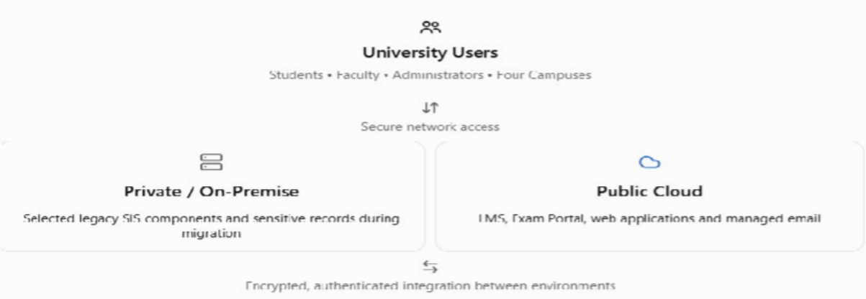

Figure 1.1: Conceptual hybrid cloud model proposed for the university.

  - Mapping Cloud Characteristics to University Problems:

The university faces three major infrastructure challenges.

Problem 1 – Underutilization of Physical Servers:
The existing 12 physical servers operate at approximately 15% average CPU utilization, resulting in inefficient infrastructure usage and maintenance expenditure. Proposed Solution: Resource pooling allows multiple applications to share virtualized infrastructure, while measured service helps monitor consumption and identify unnecessary resource allocation.

Problem 2 – Performance Issues During Peak Demand
During admissions, result publication and online examinations, server utilization exceeds 95%, potentially causing slow responses and service interruptions.
Proposed Solution: Rapid elasticity enables cloud resources to scale according to demand, while on-demand self-service supports faster provisioning of additional computing capacity.

Problem 3 – Slow Infrastructure Expansion
Purchasing and installing new physical servers takes approximately 6–8 weeks, restricting the university's ability to respond quickly to increasing requirements.
Proposed Solution: On-demand self-service reduces infrastructure provisioning time, while broad network access enables centralized delivery of university services across multiple campuses.

Benefits of Cloud Adoption:

Cloud adoption provides several advantages to the university:

- Cost Optimization: Reduces dependence on dedicated physical servers and supports usage-based resource allocation.
- Scalability: Enables dynamic resource allocation during admissions, examinations and result publication.
- Improved Accessibility: Provides centralized access to university applications across campuses through internet-enabled devices.

- Better Availability: Supports redundant infrastructure, automated backups and disaster recovery when properly configured.
- Simplified Management: Enables centralized monitoring, automated provisioning and more efficient infrastructure administration.

Limitations of Cloud Adoption:

Despite these advantages, cloud adoption introduces certain challenges.

Data Security and Privacy: Sensitive student records require encryption, access controls and compliance with applicable data protection requirements.
Internet Dependency: Network disruptions may prevent students and staff from accessing cloud-hosted applications.
Vendor Lock-In: Dependence on provider-specific services may increase the complexity and cost of future migration.
Operational Costs: Uncontrolled resource consumption, storage and data transfer may increase recurring expenditure.
These limitations can be reduced through secure architecture, continuous monitoring, backup strategies and careful selection of cloud services.

Conclusion:

Cloud computing provides a suitable solution for modernizing the university's legacy infrastructure by improving resource utilization, scalability, accessibility and manageability.
A hybrid cloud model is proposed for the initial migration because it allows the university to retain selected legacy systems while benefiting from scalable public cloud infrastructure. This approach supports gradual modernization, cost-conscious resource management and improved service delivery across all four campuses.

TASK 2 – TRACE THE EVOLUTION AND HARDWARE EVOLUTION

Introduction:

The evolution of computing infrastructure has played a significant role in the development of modern cloud computing. Computing technology has progressed from centralized mainframe systems to distributed, virtualized and internet-based cloud environments. Each stage introduced improvements in processing power, resource sharing, scalability, accessibility and cost efficiency. These developments were supported by advancements in computer hardware, including multi-core processors, commodity servers, high-capacity storage, high-speed networking and modern data centres. In the given university scenario, understanding this evolution is essential for identifying the limitations of its existing physical server infrastructure and determining how cloud computing can support efficient resource utilization and scalable academic services.

Evolution of Computing Infrastructure:

Computing infrastructure evolved through several important stages, with each stage addressing limitations of earlier technologies.
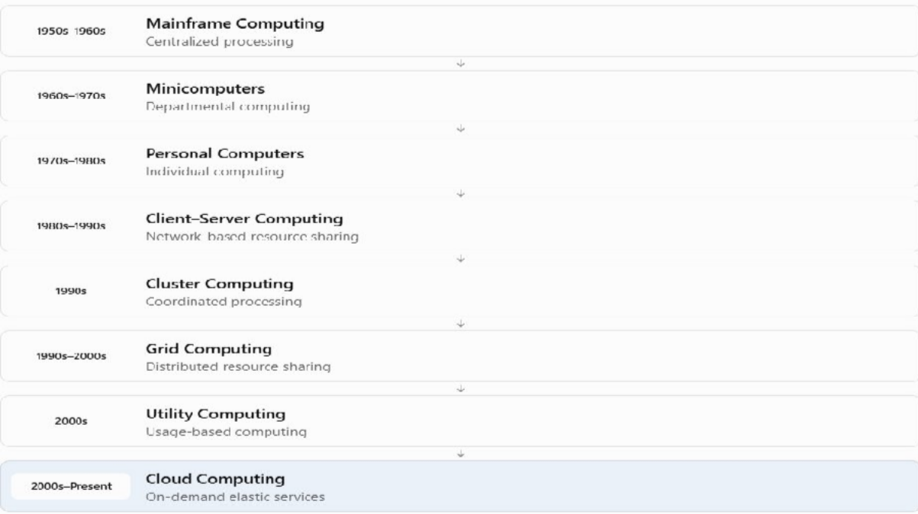

Figure 2.1: Evolution of computing infrastructure from mainframes to cloud computing. Periods are approximate and overlap.

    - Mainframe Computing (1950s–1960s)
Mainframe computers were large, centralized systems used by organizations to process significant amounts of data. Multiple users accessed a single powerful computer through terminals. Although mainframes provided centralized processing and data management, they were expensive, required specialized maintenance and were not easily accessible to smaller organizations.

Minicomputers and Personal Computers (1960s–1980s)
Minicomputers introduced smaller and more affordable computing systems that enabled individual departments and organizations to perform computing tasks independently. Personal computers further improved accessibility by providing computing capabilities directly to individual users. These developments reduced dependence on expensive mainframes, but independent systems created difficulties in centralized data management and resource sharing.

Client–Server Computing (1980s–1990s)
Client–server architecture addressed the limitations of isolated personal computers by connecting multiple client devices to centralized servers through computer networks. Applications, databases and shared resources could be managed centrally while users accessed them remotely. However, dedicated servers often experienced resource underutilization during normal operations and performance limitations during peak workloads.

Cluster and Grid Computing (1990s–2000s)
Cluster computing connected multiple computers to operate as a coordinated system, improving processing capacity and potentially increasing fault tolerance. Grid computing extended resource sharing across geographically distributed and independently managed computing systems. These approaches overcame some processing limitations of individual servers but introduced challenges in coordination, infrastructure management and resource allocation.

Utility Computing (2000s)
Utility computing introduced the concept of delivering computing resources as metered services, where organizations could obtain computing capacity according to usage rather than purchasing all the required hardware. This reduced dependence on large upfront infrastructure investments and established an important economic foundation for cloud computing. However, utility computing did not necessarily include the

automated scalability and integrated service management available in modern cloud platforms.

Cloud Computing (2000s–Present)
Cloud computing combines virtualization, distributed computing, automated resource provisioning and internet-based service delivery. It enables organizations to access shared computing resources on demand, scale infrastructure according to workload and pay based on measured consumption. Cloud computing addresses many limitations of traditional systems by improving flexibility, scalability, resource utilization and infrastructure management.

Hardware Evolution Enabling Cloud Computing:

The development of cloud computing became possible through continuous improvements in computing hardware and networking technologies.
Multi-Core Processors: The transition from single-core to multi-core processors enabled computers to execute multiple workloads concurrently. This advancement improved processing efficiency and supported virtualization, allowing multiple virtual machines to share the computing capacity of a single physical server.
Commodity Servers: Standardized and commercially available servers made it possible to build large computing environments using relatively affordable hardware. Instead of depending on expensive specialized systems, cloud providers could combine numerous commodity servers to create scalable infrastructure.
High-Capacity Storage: Advancements in hard disk drives, solid-state drives and distributed storage technologies increased storage capacity, performance and reliability. These developments enabled cloud platforms to store large volumes of data while supporting replication, backup and recovery.
High-Speed Networking: Improvements in Ethernet, fibre-optic communication and data-centre networking enabled faster communication between servers and distributed systems. High-speed networks reduced communication bottlenecks and made remote application access and distributed cloud services more practical.
Modern Data Centres: Modern data centres integrate computing servers, storage systems, high-speed networking, power management, cooling and automated monitoring. These facilities

support large-scale infrastructure virtualization, resource pooling and reliable cloud service delivery.
Together, these hardware advancements enabled cloud computing to provide scalable, efficient and centrally managed computing services.

Identification of the University's Current Computing Stage:

The university's existing infrastructure most closely corresponds to a traditional on-premise client–server computing environment.
The university operates 12 physical servers in a single data centre to support its Student Information System, Learning Management System, Library System, Exam Portal and Email services. These applications rely on dedicated server infrastructure rather than a documented elastic cloud environment.
The servers operate at approximately 15% average CPU utilization, indicating inefficient use of computing resources. During admissions, examinations and result publication, utilization exceeds 95%, creating performance and scalability challenges. Furthermore, purchasing additional servers requires approximately 6–8 weeks, and the university has no disaster recovery site. These characteristics demonstrate the limitations of traditional dedicated-server infrastructure, particularly in resource utilization, scalability and availability. Although the scenario does not specify whether virtualization is already used, it does not describe the automated resource provisioning or elasticity associated with modern cloud computing.
Therefore, the university should gradually modernize its infrastructure through server consolidation, virtualization and the proposed hybrid cloud approach. This would allow computing resources to be allocated more efficiently while supporting increasing academic workloads.

Conclusion:

The evolution from mainframe computing to cloud computing demonstrates how advancements in hardware, networking and software architecture have improved processing capability, resource sharing, scalability and cost efficiency. Multi-core processors, commodity

servers, high-capacity storage, high-speed networks and modern data centres provided the technological foundation for cloud computing.
The university's current infrastructure represents a traditional on-premise client–server environment with limited resource efficiency and scalability. Migrating toward virtualized and cloud-based infrastructure can improve resource utilization, support peak academic workloads and provide a more flexible computing environment for future university services.

TASK 3 – ANALYSE INTERNET SOFTWARE EVOLUTION

Introduction:

Internet software evolution refers to the progressive development of software applications from simple, static web pages to interactive, distributed and cloud-hosted systems. This transformation has changed how applications are developed, deployed, accessed and maintained. Earlier software systems depended mainly on individual computers or dedicated organizational servers, whereas modern applications can deliver services through web browsers, Application Programming Interfaces (APIs) and cloud infrastructure. Technologies such as Hypertext Transfer Protocol (HTTP), Asynchronous JavaScript and XML (AJAX), Service-Oriented Architecture (SOA) and web services have enabled applications to communicate efficiently across different platforms. In the given university scenario, the Student Information System (SIS), Learning Management System (LMS), Library System, Exam Portal and Email services operate as legacy applications on dedicated physical servers. Internet software evolution provides the foundation for transforming these applications into accessible, interoperable and scalable cloud-based services.

Evolution of Internet Software:

Internet software has evolved through several important stages, each introducing new capabilities and addressing limitations of earlier approaches.

3.2.1 Static Web Pages (Web 1.0)
Static web pages were among the earliest forms of internet software. They primarily used HTML to display predefined information, such as text, images and hyperlinks. The content remained unchanged unless a developer manually updated the web page. These websites were suitable for publishing information but offered limited user interaction, personalization and database integration. For example, a university could publish admission notifications, academic calendars and examination schedules through static web pages. However, students could not directly retrieve personalized examination results or update their academic information.

3.2.2 Dynamic Web Applications
Dynamic web applications introduced server-side programming, database connectivity and interactive content generation. Technologies such as PHP, Java Servlets, ASP.NET

and database management systems enabled websites to process user requests and generate personalized responses.
This development overcame the limitations of static websites by supporting user authentication, online forms, database queries and transaction processing.
In the university, dynamic web applications enabled students to log in, register for courses, check examination results and access academic records through a centralized application.

3.2.3 Web 2.0
Web 2.0 introduced a more interactive and collaborative internet environment, emphasizing user-generated content, real-time interaction and improved user experiences.
Technologies such as JavaScript and AJAX allowed web applications to update selected parts of a page without requiring a complete page reload. This improved responsiveness and made browser-based applications more interactive.
For the university, Web 2.0 capabilities support discussion forums, online assignments, collaborative learning, student feedback systems and interactive LMS dashboards.

3.2.4 Service-Oriented Architecture (SOA)
Service-Oriented Architecture introduced an approach in which application functionality is organized into reusable services that communicate through defined interfaces. Instead of requiring every application to implement the same functionality independently, SOA allows multiple systems to access common services such as authentication, student-record retrieval and fee processing. For example, the university's SIS, Exam Portal and mobile application could use a shared student-information service. This reduces duplicated functionality and improves interoperability between different university systems. SOA can use SOAP-based or RESTful web services, depending on the application requirements and architectural design.

3.2.5 Web Mashups:
Web mashups combine data or functionality from multiple sources to create a unified application or interface. They commonly use APIs to retrieve and integrate information from different services.
In the university, a student dashboard could combine attendance information from the SIS, assignment details from the LMS, examination schedules from the Exam Portal and library borrowing information from the Library System.

This integration provides students with a centralized view of academic information without requiring them to access each application separately.

3.2.6 Cloud-Hosted Applications
Cloud-hosted applications represent a modern approach to software delivery in which applications run on cloud infrastructure and are accessed through browsers, mobile applications or APIs.
Cloud platforms can provide managed databases, application hosting, automated deployment, monitoring and elastic scaling. Unlike traditional fixed-capacity infrastructure, appropriately designed cloud applications can increase or decrease computing resources according to demand.
For the university, cloud-hosted applications can improve accessibility across four campuses and provide additional computing capacity during admissions, examinations and result publication.
These stages are not strictly separate historical generations. SOA, mashups and cloud-hosted applications are architectural approaches that developed alongside advances in interactive web technologies.

Role of Browsers, HTTP, AJAX and APIs in Internet Software:

Modern internet applications depend on several technologies that enable communication between users, application servers and cloud services.
Web Browsers: A web browser acts as the client interface through which users access internet applications. Browsers such as Google Chrome, Microsoft Edge and Mozilla Firefox interpret HTML, CSS and JavaScript to display interactive web applications. In the university, students and faculty can use browsers to access learning materials, examination results and academic records without installing separate desktop applications. Hypertext Transfer Protocol (HTTP): HTTP is an application-layer protocol that enables communication between web clients and servers using requests and responses. Methods such as GET retrieve information, while POST submits data for processing. HTTPS adds encryption through TLS to protect information transmitted over networks. For example, the university's Exam Portal can receive an authenticated HTTPS request and return a student's examination results. Asynchronous JavaScript and XML (AJAX): AJAX is a web development technique that allows applications to exchange data with servers asynchronously without reloading the entire webpage. Although its name refers to XML, modern AJAX applications commonly use JSON. In the university's

LMS, AJAX can dynamically update assignment submissions, attendance information and notifications, improving responsiveness and user experience. Application Programming Interfaces (APIs): APIs provide defined interfaces through which independent software systems exchange data and access functionality. RESTful APIs commonly use HTTP methods and JSON, while SOAP services use structured XML messages. In the university, APIs can connect the SIS, LMS, Exam Portal and Library System, enabling controlled data exchange and supporting future mobile applications.
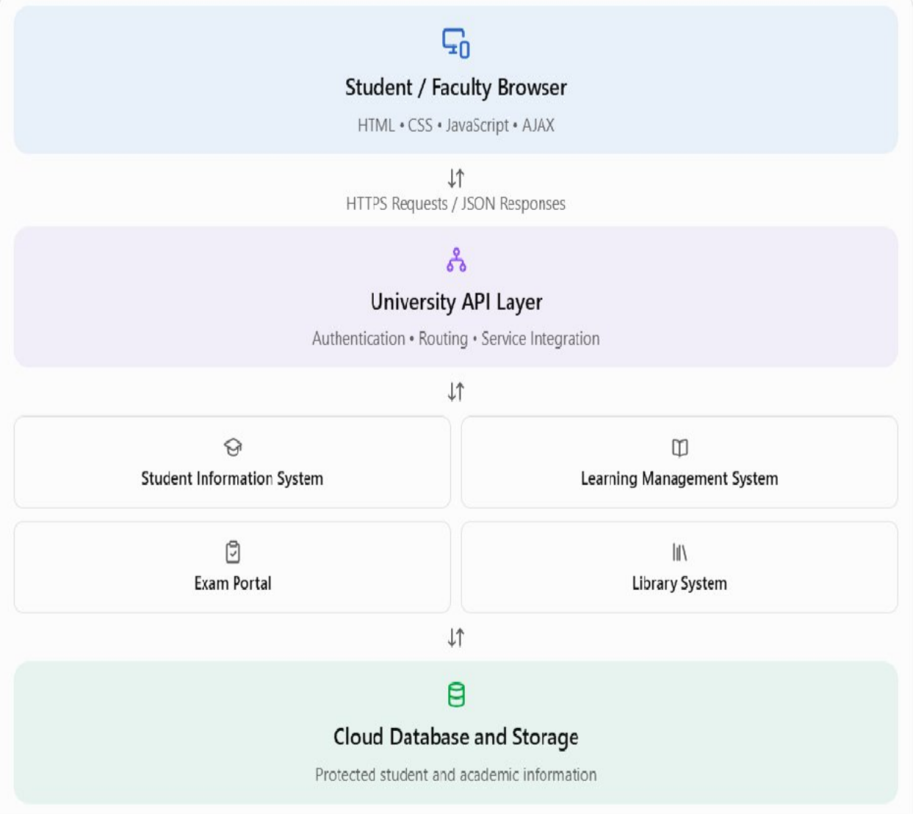

Figure 3.1: Proposed browser-to-cloud communication architecture using HTTPS and APIs. This is a conceptual design.
  - Comparison of Desktop, Client–Server and Web-Delivered Software:

The evolution of software delivery can be understood by comparing three major application models.

Feature | Desktop Software | Client–Server Software | Web-Delivered Software
Installation | Installed locally | Client installation may be required | Usually accessed through browser
Data storage | Often local | Primarily centralized server | Server or cloud storage
Accessibility | Device-dependent | Network-dependent | Accessible through supported internet-connected devices
Maintenance | Updates on individual devices | Server and possibly client updates | Centralized application updates

Desktop software provides local processing but may require individual installation and maintenance. Client–server software improves centralized data management but often depends on fixed server infrastructure. Web-delivered software simplifies client access and centralized updates, while cloud hosting can provide additional scalability when applications are designed appropriately.
For the university, web-delivered applications are suitable because students and staff across four campuses need consistent access to academic services without maintaining separate software installations on every device.

Impact of Internet Software Evolution on the University's Applications:

Internet software evolution directly influences how the university's five existing applications should be modernized.
The Student Information System (SIS) can provide secure web interfaces and APIs for student profiles, attendance, course registration and academic records. Instead of requiring other applications to access its database directly, the SIS can expose authenticated services with controlled permissions.
The Learning Management System (LMS) can adopt interactive web technologies to support online lectures, assignment submission, learning materials and student–faculty collaboration.

AJAX-based interfaces can improve responsiveness by updating content without complete page reloads.
The Library System can provide web-based catalogue searches, book availability information and borrowing records. API integration can allow relevant library information to appear within the university's student portal.The Exam Portal can use secure web services for examination schedules, registration and result retrieval. Cloud-hosted application components can be designed to scale during peak examination periods, while authentication and access controls protect sensitive academic information.
The Email System can be delivered through a managed web-based email service, reducing the need to maintain a dedicated university email server.An API-based architecture also prepares the university for its proposed mobile application and integration with 40 affiliated colleges. Such integration must include authentication, authorization, rate limiting and appropriate separation of college-specific data.
The proposed modernization does not require immediately rewriting every monolithic application. Existing systems can initially be integrated through secure APIs and gradually modernized according to technical feasibility, cost and operational risk.

Conclusion:

The evolution of internet software from static web pages to dynamic applications, Web 2.0, Service-Oriented Architecture, mashups and cloud-hosted systems has transformed software delivery into a more interactive, interoperable and scalable model.
Web browsers, HTTP, AJAX and APIs provide the essential technologies for accessing applications, exchanging information and integrating independent services over networks.
For the university, adopting web-based applications and secure API integration can improve accessibility, simplify maintenance, enable communication between academic systems and support future cloud migration. This approach provides a foundation for modernizing the university's legacy infrastructure while meeting growing academic and administrative requirements.

TASK 4 – APPLY SERVER VIRTUALIZATION

Introduction:
Server virtualization enables several independent virtual machines (VMs) to run on shared physical hardware. The university currently operates 12 dedicated physical servers for its Student Information System (SIS), Learning Management System (LMS), Library System, Exam Portal and Email service. Their average CPU utilization is 15%, although demand exceeds 95% during admissions and examinations. Virtualization can reduce idle capacity and improve management, but peak demand and fault tolerance must be assessed before selecting a production host count.

Hypervisors and Their Operation:
A hypervisor, or Virtual Machine Monitor, allocates physical CPU, RAM, storage and networking to guest virtual machines. It schedules processor access, manages virtual memory and devices, and isolates guests. A Type-1 (bare-metal) hypervisor runs directly on server hardware; examples include VMware ESXi, Microsoft Hyper-V and Xen. A Type-2 (hosted) hypervisor runs on a host operating system; examples include Oracle VirtualBox and VMware Workstation. A Type-1 hypervisor is recommended for production university workloads, while VirtualBox is appropriate for laboratory testing.
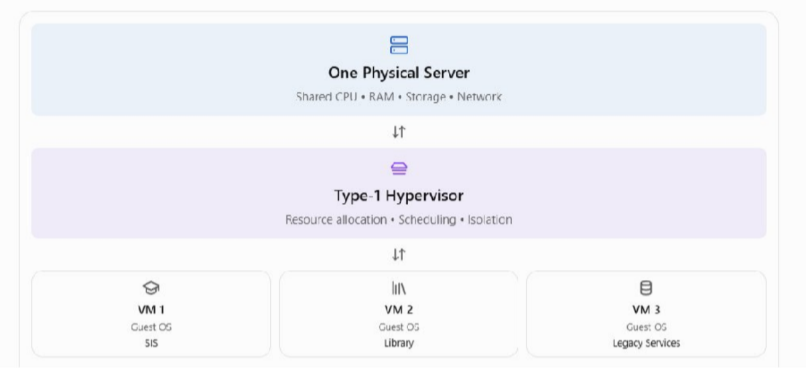

Figure 4.1 – Conceptual virtualization stack: Physical server (CPU/RAM/Storage/Network) → Type-1 hypervisor → VM 1 (SIS), VM 2 (Library), VM 3 (Legacy Email). Each VM contains its own guest operating system.

Comparison of Virtualization Approaches:

Approach | Operation | Suitability / limitation
Full virtualization | Unmodified guest OS uses virtual hardware | Legacy compatibility; greater overhead than  containers
Para-virtualization | Guest-aware components communicate efficiently  with hypervisor | Efficient I/O; compatible guest support required
OS-level virtualization | Containers share host OS kernel | Lightweight scalable services; shared-kernel  constraints

Proposed VM and Container Allocation:
The SIS should initially run in a VM because its monolithic design may depend on existing operating-system libraries and configuration. The Library System should likewise remain in a VM until its dependencies are assessed. The Email service may use a transitional VM before migration to managed SaaS. The LMS web tier and Exam Portal web tier are candidates for containers after confirming compatibility or refactoring them into deployable components. Their sessions, submissions and persistent records must reside in shared databases or storage, not in disposable container filesystems. This allocation is a proposed migration strategy; actual compatibility has not been verified.

Worked Consolidation Calculation:
Assumptions: all 12 existing servers have equal processing capacity; average utilization reflects aggregate demand; replacement hosts have capacity equivalent to one existing server; the target is 70% host CPU utilization. Memory, storage I/O, networking, hypervisor overhead and peak concurrency are excluded from this preliminary CPU-only estimate.
Total average CPU demand = 12 × 0.15 = 1.8 server-equivalents. Required hosts = ceiling (1.8 ÷ 0.70) = ceiling (2.5714) = 3 physical hosts. Consolidation ratio = 12 ÷ 3 = 4:1.
Theoretical reduction = ((12 − 3) ÷ 12) × 100 = 75%.

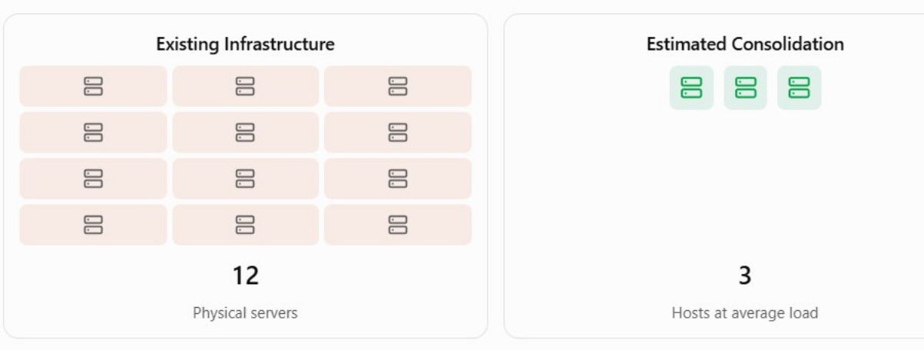

Figure 4.2 – Illustrative consolidation: 12 dedicated servers → 3 shared virtualization hosts (average-load estimate only).
Peak-load caution: if all 12 original servers simultaneously consume 95% CPU, demand becomes 12 × 0.95 = 11.4 server-equivalents. At a 70% host target, ceiling (11.4 ÷ 0.70) = 17 equal-capacity hosts. The assessment says peaks exceed 95%, but does not establish simultaneous peaks or replacement-host capacity. Therefore, neither 3 nor 17 is a verified production requirement. Final sizing must use concurrent peak measurements, host specifications, RAM, storage I/O, networking, headroom and failover capacity.

Virtualization Benefits:
Live migration can transfer a running VM between compatible hosts with little interruption during planned maintenance. Snapshots capture a VM state before changes and can support short-term rollback, but they are not a substitute for independent backups. Resource over-commitment allocates more virtual resources than physically available on the expectation that workloads will not peak simultaneously; it can improve normal utilization but may degrade performance during examination periods.

Risks and Controls:
A noisy-neighbour workload can consume CPU, RAM or storage bandwidth and slow other VMs; use reservations, limits, monitoring and workload placement. Hypervisor or host failure can interrupt several applications at once; use redundant hosts, tested backups and high-availability arrangements. Weak security isolation or management-plane compromise can expose multiple workloads; enforce patching, least-privilege access, network segmentation, encryption and auditing. Container kernel sharing also requires additional hardening.

Recommendation and Conclusion:
Use Type-1 hypervisor-based VMs for legacy workloads and containers for compatible modernized application tiers. The worked average-load estimate is three equal-capacity hosts, but production consolidation must be validated against real peak workloads and resilience requirements. This hybrid virtualization strategy supports gradual cloud migration while preserving application compatibility and improving resource sharing.
Implementation evidence: Task 4 requires a justified plan and calculation, not a running deployment. Actual VM/container execution and screenshots belong to Task 9.

TASK 5 – APPLY WEB SERVICES

  - Introduction and Role in Cloud Computing:
Web services expose defined application functions across a network so that different systems can exchange information without direct access to each other’s internal databases. In cloud computing, they connect components hosted on VMs, containers or managed platforms. Service-Oriented Architecture (SOA) organizes functionality into reusable, loosely coupled services with explicit interfaces. The university’s SIS, LMS, Library, Exam Portal and Email are currently separate monolithic applications without public mobile or partner interfaces. A secured API layer can enable gradual integration without immediate replacement of every legacy application.
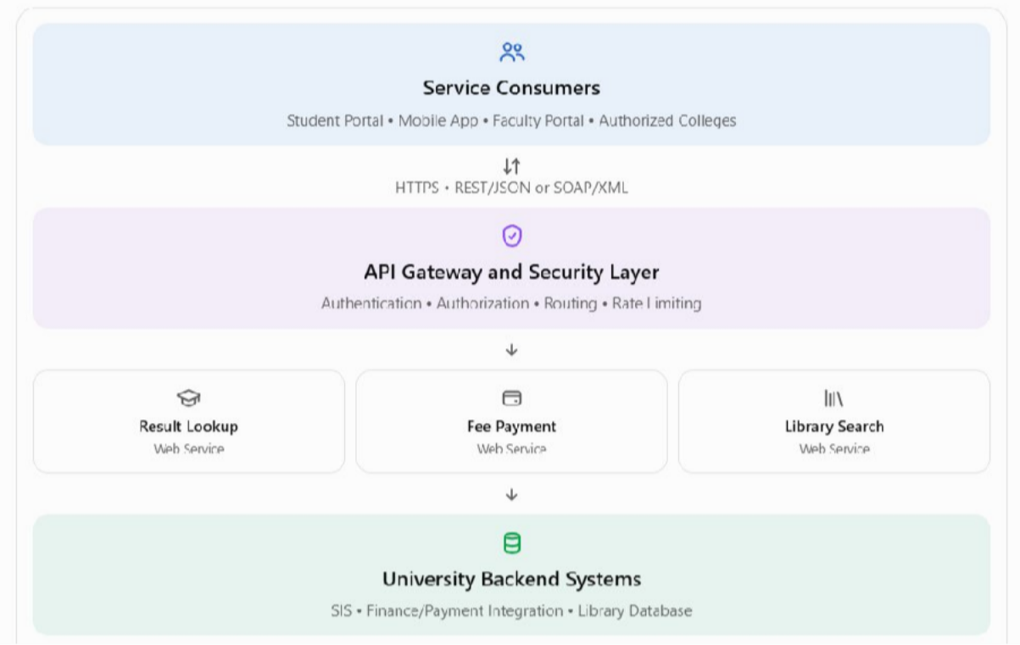

Figure 5.1 – Proposed service flow

  - SOAP, WSDL, UDDI and REST:
SOAP is an XML messaging protocol with an envelope, header and body; it can support formal enterprise messaging and WS-Security. WSDL is an XML description of service operations, message formats and bindings, typically used with SOAP. UDDI is a framework for publishing and discovering services, though modern deployments often use internal API catalogues instead. REST is an architectural style that exposes resources through standard HTTP methods;

JSON is common, but XML is also possible. GET retrieves, POST submits or creates, PUT replaces, PATCH partially updates and DELETE removes resources.

Technology | Purpose | University relevance
SOAP | Structured XML messaging protocol | Existing enterprise or financial integrations  requiring formal contracts
WSDL | Machine-readable service  contract | Documents SOAP  operations and endpoints
UDDI | Service publication/discovery  registry | Optional; internal API catalogue is often simpler
REST | Resource-oriented API  architecture using HTTP | Student, library and  mobile-facing services

Service 1 – Examination Result Lookup (REST):
Endpoint: GET https://api.university.example/v1/students/STU1001/results?semester=4. The requester must be authenticated and authorized to view the selected record. The example domain and student records are illustrative, not live services.
GET /v1/students/STU1001/results?semester=4 HTTP/1.1 Host: api.university.example
Authorization: Bearer <access_token> Accept: application/json
Sample response (HTTP 200 OK):

{“studentId”:”STU1001”,”semester”:4,”results”:[{“courseCode”:”CSA15”,”grade”:”A”}
,{“courseCode”:”CSA14”,”grade”:”B+”}],” status”:”Published”}
REST is appropriate because this is a read-only resource retrieval. HTTPS, record-level authorization and appropriate no-store caching controls protect sensitive academic results.

Service 2 – Fee Payment Initiation (REST; SOAP if required):
Endpoint: POST https://api.university.example/v1/payments. The server must independently verify the fee amount, student identity and authorization. An idempotency key help prevent

duplicate initiation; a verified payment-provider confirmation is needed before marking a fee as paid.
POST /v1/payments HTTP/1.1 Host: api.university.example
Authorization: Bearer <access_token> Content-Type: application/json Idempotency-Key: fee-STU1001-2026-001

{"studentId":"STU1001","feeType":"Semester Fee","amount":25000,"currency":"INR"} Sample response (HTTP 201 Created):
{"paymentId":"PAY2026001","studentId":"STU1001","amount":25000,"currency":"INR ","status":"PENDING","message":"Payment initiated successfully"}
REST/JSON suits new web and mobile clients, while SOAP may be necessary for an existing finance provider that mandates WSDL, XML or WS-* standards. Neither technology alone guarantees transaction safety.

Service 3 – Library Catalogue Search (REST):
Endpoint: GET https://api.university.example/v1/library/books?query=cloud. The search returns catalogue metadata without granting direct database access.
GET /v1/library/books?query=cloud HTTP/1.1 Host: api.university.example
Accept: application/json Sample response (HTTP 200 OK):
{"query":"cloud","totalResults":2,"books":[{"bookId":"LIB101","title":"Introduction to Cloud Computing","availableCopies":5},{"bookId":"LIB102","title":"Cloud Infrastructure Fundamentals","availableCopies":3}]}

REST is appropriate for lightweight catalogue retrieval. Public searches may be allowed with rate limits, but personal borrowing records require authentication.

Recommended Service Choices:

Function | Method | Choice | Justification
Result lookup | GET | REST/JSON | Standardized authorized read  access
Fee payment | POST | REST/JSON;  SOAP when mandated | New-client simplicity; existing contractual  compatibility
Library search | GET | REST/JSON | Lightweight search and mobile  integration

Security, Reliability and Conclusion:
The API gateway should enforce HTTPS, authentication, per-resource authorization, input validation, rate limits, audit logs and monitoring. Sensitive data must be encrypted and exposed only to authorized users or colleges. Service metrics and horizontal scaling can help with admission and examination peaks. These proposed web services enable interoperable, reusable access to academic functions and support the university’s gradual migration toward a cloud-based architecture.

TASK 6 – ANALYZE THE SERVICE MODELS: IAAS, PAAS AND SAAS

1 Introduction:
Cloud service models define how computing capabilities are delivered and how operational responsibility is divided between the cloud provider and the university. The university currently operates the Student Information System (SIS), Learning Management System (LMS), Library System, Exam Portal and Email on ageing on-premise servers. A single service model is unlikely to provide the best combination of compatibility, scalability, cost control and maintenance for all five applications. A mixed approach is therefore proposed, with the classification based on the characteristics of each workload and the migration effort required.

Infrastructure as a Service (IaaS):
Infrastructure as a Service provides virtualized computing resources, such as virtual machines, virtual networks and storage, on demand. The provider manages physical data-centre facilities, physical servers and the underlying virtualization platform. The university remains responsible for the guest operating systems, patches, application runtime, application software, data, identity configuration and most workload-level security. This gives the university considerable control over legacy application environments, but requires experienced administrators and continuing maintenance.
For example, Amazon EC2 is an IaaS offering that could host an existing SIS or Library System inside a virtual machine. Such a migration may preserve legacy operating-system and runtime dependencies while reducing the need to purchase replacement physical servers. It does not automatically modernize the application or guarantee high availability: backups, patching, recovery and capacity planning remain necessary.

Platform as a Service (PaaS):
Platform as a Service supplies a managed environment for deploying applications. The provider generally manages the physical infrastructure, virtualization, operating system and supported application runtime, while the university manages its application code, business logic, data and relevant security configuration. This reduces operating-system administration and can simplify deployment and scaling, but may constrain runtime versions, supported technologies and portability.
Google App Engine is a real PaaS example. A modernized LMS web application or Exam Portal API could be deployed to a supported PaaS environment, with application instances scaled as demand

changes. This is a proposed future deployment: the existing monolithic programs must first be assessed and, where necessary, refactored to handle stateless execution, external session storage and managed database connectivity.

Software as a Service (SaaS):
Software as a Service delivers a complete application operated by a provider, normally through a browser or mobile client. The provider manages the application, runtime, operating system and physical infrastructure. The university remains responsible for user access, data governance, tenant settings, licensing choices, appropriate configuration and the security of information it enters into the service. SaaS can reduce the need to maintain commodity applications internally, although customization and provider dependence may be significant.
Microsoft 365 Exchange Online is a real SaaS example for university email. Migrating email to such a service could eliminate the need to operate an independent mail server, provided that account migration, identity integration, retention requirements, licensing and data-protection obligations are satisfied.

Layer-Wise Responsibility Comparison:
The following table distinguishes the primary management responsibilities. Shared-responsibility details vary by provider and specific product, so the table represents the standard conceptual models rather than a contractual allocation.

Table 6.1: Typical provider–university responsibility allocation across service models.

Technology layer | IaaS | PaaS | SaaS
Physical facilities, servers and networking | Provider | Provider | Provider
Virtualization / infrastructure platform | Provider | Provider | Provider
Guest OS and patching | University | Provider | Provider
Application runtime / middleware | University | Provider (supported runtime) | Provider

Application-Wise Service Model Selection:
The proposed categorization below prioritizes compatibility for legacy systems, elastic hosting for peak-sensitive applications, and outsourcing of standard communication services. The university has not supplied its actual operating systems, licenses or source-code dependencies; therefore, these selections are reasoned design recommendations requiring a migration assessment.

Table 6.2: Proposed service-model categorization for the five university applications.

University application | Proposed model | Primary justification
Student Information System (SIS) | IaaS | Preserves legacy runtime and control of critical academic logic during phased migration.
Learning Management System (LMS) | PaaS | Managed application deployment and scaling after compatibility checks or modernization.
Library Management System | IaaS | Supports existing library software and database dependencies with minimal immediate rewriting.
Exam Portal | PaaS | Supports deployment of scalable web/API components for admissions and examination peaks.
University Email | SaaS | Outsources routine mail hosting, patching and infrastructure administration.

Justification of the Five Application Decisions:
Student Information System (IaaS): The SIS is a critical system of record containing student identity, enrolment and academic information. Because the scenario describes monolithic legacy software, an

initial lift-and-shift to a virtual machine is less disruptive than an immediate rewrite. IaaS permits the university to retain control of the runtime and database integration while introducing backups, access controls and a staged migration plan. The trade-off is that the university continues to patch and operate the application and guest OS.
Learning Management System (PaaS): The LMS supports content delivery, course access, assignments and student interaction. Its application tier may be suited to PaaS because managed deployment and automatic scaling can reduce the administration burden across four campuses. This is conditional on compatibility: a monolithic LMS that depends on local files or server-side sessions must be adapted or retain an IaaS deployment until modernization is feasible. Course content and durable records should use persistent storage and databases independent of transient application instances.
Library Management System (IaaS): Library software often contains specialized catalogue, circulation and database dependencies. As those dependencies are unknown in the assignment scenario, IaaS is a cautious initial choice that allows the existing software to operate in a controlled virtual environment.
The university can later introduce REST APIs for catalogue search and assess whether a suitable SaaS library product offers acceptable data migration and customization options.
Exam Portal (PaaS): The Exam Portal is especially sensitive to sharp peaks during online examinations and result publication. A modernized, stateless web/API tier on PaaS can scale horizontally and reduce manual server provisioning. However, database throughput, authentication, submission durability and concurrency must be tested separately; adding web instances alone does not solve database bottlenecks.
The university should retain stable storage for examination submissions and configure observability, load testing and failure recovery.
Email (SaaS): Email is a standardized communication service rather than a distinctive university-developed academic application. A managed SaaS email platform can reduce the burden of mail-server patching, anti-spam operations and infrastructure maintenance.
The university must evaluate per-user subscription costs for approximately 27,000 users, eligibility for educational licensing, retention rules, migration effort and integration with its identity system before contracting with a provider.

Comparison of Control, Cost, Scalability, Maintenance and Lock-In:

Table 6.3: Qualitative comparison; actual costs and scaling depend on the selected services and workload.

Criterion | IaaS | PaaS | SaaS
Control | High: OS, runtime and application | Medium: code and supported configuration | Lower: tenant and application settings
Cost structure | Usage charges plus administration | Platform usage plus development | Usually, subscriptions or licenses
Scalability | University configures scaling | Managed scaling often available | Provider operates application scale
Maintenance effort | Highest of the three | Moderate; provider manages platform | Lowest infrastructure effort
Vendor lock-in | VM formats and provider services | Runtime and platform integrations | Data export, workflows and licensing

IaaS offers the greatest infrastructure control and can be useful for older applications, but the university retains considerable operational responsibility. PaaS reduces platform maintenance and can make scaling more convenient, although developers must respect provider runtime and deployment constraints. SaaS is generally the simplest model to operate for standardized services such as email, but its recurring licensing costs and restrictions on customization must be assessed. None of the models is inherently the cheapest: the correct comparison must include migration, staffing, licensing, data transfer, resilience and three-year operational costs, which are evaluated in Task 10.

Recommended Service-Model Strategy and Conclusion:
A mixed IaaS–PaaS–SaaS strategy is recommended for the university. IaaS provides a controlled transition path for the SIS and Library System; PaaS is the target for compatible or modernized LMS and Exam Portal application components; and SaaS is appropriate for email after procurement and

migration checks. The model mix reduces the risk of rewriting all five legacy systems simultaneously while aligning management effort with application requirements. Final selection should be validated through application dependency analysis, load tests, data-protection review and a total-cost comparison.

TASK 7 – EXAMINE XAAS (ANYTHING-AS-A-SERVICE)

Introduction:
Anything-as-a-Service (XaaS) is a broad term for computing capabilities delivered as services over a network, rather than acquired and operated entirely as local assets. It extends the familiar IaaS, PaaS and SaaS categories to specialized offerings such as managed databases, backup, disaster recovery, functions and security services. XaaS can help the university modernize specific capabilities without building and maintaining every supporting platform itself. However, each additional managed service creates operational, contractual, security and integration responsibilities that must be evaluated.

Important XaaS Variants:

    - Database as a Service (DBaaS)
DBaaS supplies a managed database platform in which the provider typically handles database infrastructure, routine patching, monitoring options and certain backup features. The university still controls its schema, queries, access permissions, data quality and application integration. A managed relational database could support student profiles, enrolment data and examination records, provided that transaction performance, encryption, recovery objectives and compliance requirements are met. Amazon RDS and Azure SQL Database are examples of managed database offerings.

Disaster Recovery as a Service (DRaaS)
DRaaS supports recovery of workloads and data following major failures by using replication, recovery orchestration and tested restoration procedures in a separate environment. The university currently has no disaster recovery site, making this capability directly relevant. A DRaaS arrangement could reduce recovery time after a primary data-centre or regional outage, but successful recovery depends on configured replication, documented runbooks, sufficient capacity and periodic recovery tests. Recovery Point Objective (RPO) and Recovery Time Objective (RTO) must be defined rather than assumed.

Function as a Service (FaaS)
FaaS executes short-lived, event-driven functions without the university managing a continuously running application server. It may be useful for notifications, file-processing events or scheduled administrative integrations. For example, an examination-result

publication event could trigger a notification function. The university should assess execution limits, cold-start behavior, cost at high invocation rates and the suitability of each task for event-driven processing. AWS Lambda is one example.

Backend / Mobile Backend as a Service (BaaS / MBaaS)
BaaS and MBaaS provide managed backend capabilities such as authentication, push notifications, file storage and mobile application integration. These offerings could accelerate the planned university mobile app by reducing the amount of custom backend infrastructure required. Nevertheless, mobile clients must not bypass authorization checks to access sensitive student records, and the university must verify how the service handle’s identity, audit logging and data residency. Firebase is an example of a mobile-oriented backend platform.

Security as a Service (SECaaS)
Security-as-a-Service delivers specialized security capabilities such as identity protection, threat monitoring, web application filtering and managed security analytics. It could help protect the university’s student portal and APIs from unauthorized access and common internet threats. Security services supplement, rather than replace, secure coding, least-privilege authorization, data encryption and incident-response planning. Product coverage and responsibility vary significantly between vendors.

Desktop as a Service (DaaS)
Desktop-as-a-Service provides remotely hosted desktop environments accessed over a network. The university could consider it for shared computer laboratories or temporary administrative access, where centralized software images and controlled user environments are valuable. Its suitability depends on network quality, application licensing, endpoint devices and per-user costs. DaaS is not essential to the initial migration of the five core university applications.

Selection of Two XaaS Offerings for the University:
The two recommended XaaS capabilities are Database as a Service (DBaaS) and Disaster Recovery as a Service (DRaaS). They address different but complementary weaknesses in the scenario: the need for manageable, durable academic data services and the absence of a disaster recovery site.

DBaaS is recommended because academic applications depend on reliable, consistent student and examination records. A managed database can reduce routine infrastructure administration and support automated backups, monitoring and scalable storage options. For the SIS and Exam Portal, the university should evaluate relational consistency, connection limits, query performance and high-availability options. The university must still design schemas, manage data access and test restore procedures. DBaaS may be introduced gradually through controlled database migration rather than a simultaneous move of all application data.
DRaaS is recommended because all five existing applications are concentrated in one on-premise data centre and there is no secondary recovery location. Replication and a tested recovery plan can reduce the consequences of hardware failure, site disruption or regional incidents. The university should classify systems by criticality, specify acceptable RPO/RTO values, protect backup copies from unauthorized modification and conduct scheduled recovery drills. DRaaS is not equivalent to continuous high availability: a recovery operation may still involve service interruption, and the chosen service must be sized and tested.

Table 7.1: Justification for selecting DBaaS and DRaaS.

Recommended XaaS | University problem addressed | Expected value | Validation needed
DBaaS | Complex database operation and peak-sensitive academic data | Managed operations and durability features | Transactions, performance, backup/restore and data governance
DRaaS | Single data centre with no DR site | Recovery capability after major failures | RPO/RTO, replication integrity and recovery drills

Risks of Over-Reliance on Multiple Service Providers:
Using several XaaS vendors can introduce vendor lock-in when applications depend on proprietary APIs, data formats or management tools. Migrating to another provider may require code changes, data conversion and additional expenditure. The university should prefer documented interfaces,

maintain data-export procedures and avoid unnecessary dependence on provider-specific features when a portable alternative meets the requirements.
Multiple services also increase integration and availability dependencies. An outage in an identity provider, database service or networking link can affect applications even when the application host itself remains operational. The university should map critical dependencies, monitor service health, define fallback behavior where feasible and avoid assuming that individual vendor uptime commitments guarantee end-to-end university availability.
Data privacy and security responsibilities become more complicated when student information crosses multiple providers or regions. Contracts must clarify data location, access permissions, encryption, audit logging, incident reporting and deletion arrangements. The university should also control service accounts, apply least privilege and review vendor security documentation.
Finally, XaaS can create unpredictable recurring costs through database capacity, backup retention, cross-region replication, network egress and per-user licensing. A centralized cloud budget, usage alerts, cost allocation and regular provider reviews are necessary. Staff must have sufficient skills to troubleshoot incidents that span several platforms, and contractual exit plans should be established before sensitive data is committed.

Conclusion:
XaaS extends cloud computing by making specialized capabilities available as managed services. DBaaS, DRaaS, FaaS, BaaS/MBaaS, SECaaS and DaaS each offer potential value, but they solve different problems. For the university, DBaaS and DRaaS are the most directly justified initial selections because they support dependable academic data management and address the lack of a disaster recovery site. Their adoption should be accompanied by clear ownership, security controls, tested recovery procedures, cost monitoring and portability planning.

TASK 8 – DESIGN THE CLOUD SOLUTION ARCHITECTURE

Introduction:
The university requires a cloud architecture that modernizes five legacy applications running on 12 dedicated physical servers while supporting approximately 25,000 students and 2,000 staff across four campuses. Its existing environment has approximately 15% average CPU utilization, experiences peaks above 95%, and lacks a disaster recovery site. The proposed solution therefore combines a phased hybrid deployment, virtual machines for legacy dependencies, managed application platforms for scalable web workloads, and secure web services for interoperability. All sizing decisions below are proposals that must be tested against actual workload measurements.

Proposed Architecture Diagram:

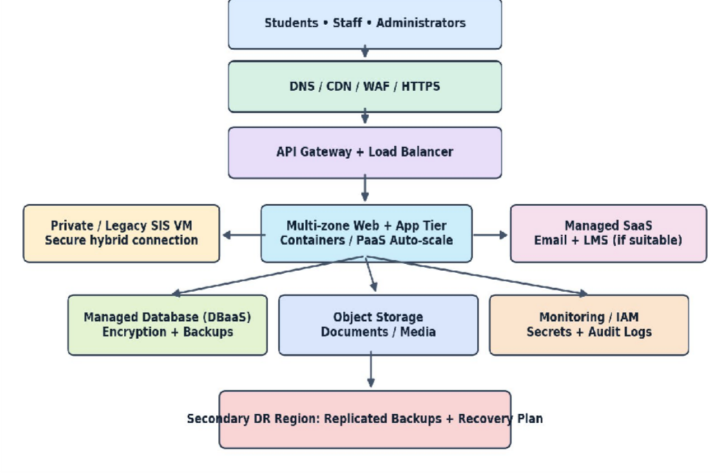

Figure 8.1: Proposed hybrid university cloud architecture showing users, load balancing, API layer, application tier, database, storage and disaster recovery region.

  - Deployment and Service Model of Each Component:

Component | Deployment / service model | Reason
Users, DNS, CDN, WAF | Public cloud managed services | Global reach, edge protection and reduced origin traffic
Load balancer and API gateway | Public cloud PaaS / managed service | Distribute requests, authenticate and rate-limit APIs
Legacy SIS and library components | Private/on-premise or cloud IaaS VMs | Retain legacy OS and dependencies during phased migration
Exam web tier and compatible LMS modules | Public cloud PaaS containers | Scale stateless instances for seasonal peaks
Email | SaaS | Reduce mail-server patching and operations
Database | Managed DBaaS / PaaS | Automated maintenance, backup and availability options
Documents and learning media | Object storage / storage service | Durable and scalable content storage
DR and monitoring | DRaaS plus managed monitoring | Recovery procedures, alerts and audit evidence

Architectural Component Justification:
Students and staff reach the university through HTTPS, optionally using a CDN for cacheable static content. A web application firewall filters malicious traffic, and a load balancer distributes legitimate requests across healthy application instances. The API gateway provides a single controlled entry point for result lookup, library search and payment initiation, applying authentication, per-client authorization, quotas and request logging. These controls are especially important because the underlying monolithic applications were not originally designed for external integration.

The application tier contains independently deployable web services on managed containers or a PaaS environment. Stateless request handlers may scale horizontally; persistent sessions, examination submissions and student records must be held in shared, durable data services. Selected legacy SIS and library workloads remain in isolated virtual machines until compatibility and migration tests permit modernization. Managed databases are configured with private network access, backups and replication as appropriate; object storage holds documents and media rather than sensitive transactional state. Email is a strong SaaS candidate, reducing operational overhead.

Elasticity During Admission and Examination Peaks:
Autoscaling should use measured indicators such as concurrent requests, CPU utilization, queue length and response latency. During admission opening or result publication, the load balancer routes traffic to additional application instances. Scaling down after peak demand limits unnecessary expenditure. Minimum instances prevent cold-start delays for critical portals, while database connection pools, query indexes, caching and asynchronous queues protect backend bottlenecks. Autoscaling alone does not guarantee capacity: load tests must establish throughput; acceptable latency and the database write rate before production rollout.

Security, Availability and Disaster Recovery:
Identity management should enforce least-privilege roles, multi-factor authentication for administrators, student-level authorization and encrypted communication using TLS. Sensitive data should be encrypted at rest, with encryption keys and secrets managed separately from source code. Network segmentation and private database endpoints reduce exposure. Production application instances should be distributed across multiple availability zones, with health checks, monitored backups, restoration drills and documented recovery time and recovery point objectives. A second region is proposed for disaster recovery backups and failover procedures; multi-region active service is not assumed because it would increase cost and complexity.

Conclusion:
A phased hybrid architecture balances legacy compatibility with cloud elasticity. Virtual machines protect existing workloads during migration; managed application services and APIs improve interoperability and scaling; DBaaS, secure storage, multi-zone redundancy and DR planning address manageability and resilience. The final infrastructure size must be validated through actual measurements and testing.

TASK 9 – HANDS-ON IMPLEMENTATION AND DOCUMENTATION

Aim and Proof-of-Concept Scope:
Implement a small, reproducible university REST service using a Docker container and deploy a separate PaaS component such as a static website. The proof-of-concept demonstrates the web/application tier, API communication and managed hosting concepts in Task 8. This report supplies implementation-ready code and a test procedure; it does not claim that a container was run, a cloud service was deployed, or screenshots were captured.

Tools and Environment:
A Windows, Linux or macOS computer with Docker Desktop or Docker Engine, Python source files, a text editor and a browser or curl client is sufficient for the container portion. A free-tier static hosting service such as Firebase Hosting, Azure Static Web Apps or a comparable PaaS may be used for the separate hosted component. Account creation, free-tier eligibility, billing and region selection must be verified by the student before deployment.

REST API Source Code:
Create a folder named university-api. Save the following source as app.py. It returns a sample academic result for an authorized demonstration endpoint; all records are fictitious and the example must not be used for production student data.
from flask import Flask, jsonify app = Flask( name )
@app.get("/health") def health():
return jsonify(status="ok"), 200 @app.get("/api/results/<student_id>") def results(student_id):
if student_id != "STU1001":
return jsonify(error="Student not found"), 404 return jsonify(studentId="STU1001", semester=4,

course="Cloud Computing", grade="A"), 200 if name == " main ":
app.run(host="0.0.0.0", port=5000)

Dependency and Docker Configuration:
Create requirements.txt containing Flask>=3.0,<4.0. Create a file named Dockerfile with the following instructions. For a reproducible final submission, pin and record the exact resolved Flask version and image digest used in the tested environment.
FROM python:3.12-slim WORKDIR /app
COPY requirements.txt .
RUN pip install --no-cache-dir -r requirements.txt COPY app.py .
EXPOSE 5000
CMD ["python", "app.py"]

Container Build and Run:
Open a terminal inside university-api and execute the following commands in order: docker build -t university-api:demo .
docker run --rm -d --name university-api -p 5000:5000 university-api:demo docker ps
docker logs university-api

PaaS Component Deployment:
For the second required component, create an index.html page headed “University Cloud Services Demonstration” with a short description and a link to the local API demonstration. Deploy the static page using the chosen provider’s documented static hosting workflow. For Firebase Hosting, the typical process includes installing the Firebase CLI, signing in, initializing Hosting in the project directory, choosing the public directory and running firebase deploy --only hosting. Use the provider-generated hosting URL as the actual deployment evidence. A hosted static page is a separate PaaS

component; a link to localhost will not work for remote viewers, so the page should describe the local API or use a separately deployed HTTPS API if one is available.

Testing and Evidence Recording:

Test | Expected result | Actual status
Docker container starts | Container visible in docker ps | Not executed / evidence pending
GET /health | HTTP 200; {"status":"ok"} | Not executed / evidence pending
GET /api/results/STU1001 | HTTP 200; sample result JSON | Not executed / evidence pending
GET /api/results/UNKNOWN | HTTP 404; error JSON | Not executed / evidence pending
PaaS hosted static page | Public HTTPS URL loads | Not deployed / evidence pending

Capture authentic screenshots of the project files, docker build success, docker ps output, successful API response, HTTP 404 response, and deployed static page with its actual HTTPS address. Add annotations identifying the command, status code and outcome. Record OS version, Docker version, date, provider and any encountered errors. Do not submit simulated terminal screenshots as execution evidence.

Issues and Limitations:
Potential issues include Docker daemon not running, port 5000 already occupied, unavailable cloud-account permissions, incorrect hosting directory and blocked outbound networking. Record only issues actually encountered. The proof-of-concept uses hard-coded demonstration data and lacks production authentication, persistence, rate limiting and financial transaction handling. These omissions are deliberate and must be corrected before any real university deployment.

Result:
The proof-of-concept design, source code and testing instructions are documented and reproducible in principle. Implementation validation remains PENDING until the student runs the container, deploys the PaaS component, records actual HTTP responses and provides genuine screenshots.

TASK 10 – EVALUATE AND RECOMMEND THE FINAL SOLUTION

Evaluation Objective:
The final decision must compare continued on-premise operation, an IaaS-centric migration and a managed PaaS/SaaS strategy. Evaluation criteria are three-year total cost, scalability, availability, security, maintenance effort and vendor dependency. The comparison must remain consistent with the hybrid architecture proposed in Task 8 and recognize that the university has not supplied actual server purchase prices, electricity rates, workload measurements or provider quotations.

Three-Way Technical Comparison:

Criterion | On-premise | IaaS-centric | Hybrid PaaS/SaaS-led
Capital vs operating cost | High hardware CapEx | Lower hardware CapEx; VM OpEx | Low hardware CapEx; managed-service OpEx
Scalability | Slow procurement | VM scaling possible | App autoscaling and SaaS capacity
Availability | Local redundancy required | Cloud zones and backup configured by team | Managed options plus multi-zone design
Security | Full local responsibility | Shared responsibility; OS managed by university | Provider manages more layers; university still owns data access
Maintenance | Hardware, OS and apps | Guest OS, apps and data | Mainly application configuration, integration and data
Lock-in | Hardware / legacy dependencies | VM and cloud platform dependencies | Potentially higher managed API/provider dependency

Three-Year Cost Estimate and Assumptions:
The following is an illustrative classroom financial model in Indian rupees (INR), not a cloud quotation. Assume the comparison covers the same five application functions and a 36-month period; migration is a one-time cost. The example excludes tax, inflation, existing sunk costs and future 10× expansion. Staff and support estimates are simplified and should be replaced with local quotations and real cloud usage measurements before approval.

Cost category (INR lakh) | On-premise | IaaS-centric | Hybrid PaaS/SaaS
Upfront hardware / setup | 24.0 | 2.0 | 1.5
Migration / implementation | 2.0 | 6.0 | 7.0
Recurring infrastructure, 36 months | 18.0 | 25.2 | 20.7
Operations and support, 36 months | 18.0 | 14.4 | 10.8
Backup, DR and security, 36 months | 6.0 | 7.2 | 7.2
THREE-YEAR TOTAL | 68.0 | 54.8 | 47.2

Worked totals: On-premise = 24 + 2 + 18 + 18 + 6 = INR 68.0 lakh.
IaaS = 2 + 6 + 25.2 + 14.4 + 7.2 = INR 54.8 lakh.
Hybrid PaaS/SaaS = 1.5 + 7 + 20.7 + 10.8 + 7.2 = INR 47.2 lakh.
Under these assumptions, the hybrid option is INR 20.8 lakh lower than on-premise, or approximately 30.6%. This saving is conditional on the assumed workloads, licenses, migration effort and managed-service charges, and is not a verified forecast.

Risk Analysis and Mitigation:
Vendor lock-in can arise from provider-specific databases, APIs and identity services. The university should use documented REST contracts, portable data formats, infrastructure-as-code where practical and scheduled export testing. Student-data privacy requires encryption, least-privilege access, consent and retention policies, audit trails and compliance review. Downtime risk requires multi-zone deployment, monitored backups, tested restores, incident response and DR runbooks. A cloud skills gap can be addressed through administrator training, phased pilot migration and external support during transition. Cloud spend must be controlled with budgets, alerts, resource tagging and periodic capacity reviews.

Final Recommendation and Migration Roadmap:
A phased hybrid PaaS/SaaS-led strategy is recommended, retaining IaaS VMs for incompatible legacy SIS and library components during transition. This selection is supported by elastic handling of seasonal peaks, lower ongoing administration for email and compatible web workloads, and the illustrative cost advantage shown above. No particular vendor should be selected solely on popularity; final procurement must compare location, compliance, service-level commitments, interoperability, support and total measured cost.
Phase 1: inventory servers, application dependencies and data classification, establish identity, network security, backups and monitoring. Phase 2: migrate email first to a managed SaaS service because it is relatively separable from core academic transactions, subject to identity and mail-data validation. Phase 3: move a compatible LMS pilot and static content to managed hosting, test access and performance. Phase 4: modernize the Exam Portal web tier and expose controlled APIs for results and library search. Phase 5: migrate the SIS and library legacy components in stages, using reconciliation, rollback plans and user acceptance tests. Phase 6: conduct disaster recovery drills, optimize cost and decommission old servers only after acceptance.

Conclusion:
The hybrid PaaS/SaaS-led model offers a reasoned balance of scalability, operational simplicity and phased legacy compatibility. Its estimated three-year cost advantage is illustrative rather than verified. The university should authorize production migration only after workload profiling, security assessment, provider pricing validation and successful pilot tests.

TASK 11 – DAY-4 DESIGN CHALLENGE: RE-EVALUATE AND ADAPT

Changed Requirement and Decision:
On Day 4 the university adds a mobile application, opens student-record and fee-payment services to 40 affiliated colleges, expects 10 times its current peak workload, requires 99.9% availability and has a limited operating budget. The recommended decision is MODIFY, not retain unchanged or completely replace the original hybrid architecture. The initial design already includes APIs, managed application services and DR planning, but it requires stronger tenant isolation, higher validated capacity and more explicit availability engineering.

Impact Analysis:
The original university workload covered 25,000 students and 2,000 staff across four campuses, with occasional server peaks above 95%. The new college integrations add independent institutional clients and more external requests. A 10× peak multiplier cannot be translated into a reliable requests-per-second number because the baseline throughput and concurrent user counts are not supplied. APIs become critical contracts for mobile clients and college systems, particularly for result access, student records and payment initiation. Each college must be identified as a tenant with separate authorization policies, audit logs, quotas and strict controls preventing cross-college record access.

Evaluation of the Original Design:
The initial three-host consolidation estimate from Task 4 was derived from average CPU utilization only and cannot support a 10× peak claim. VM capacity, container replicas, database connections, payment throughput and network limits all need re-evaluation. Horizontal autoscaling helps stateless applications but does not automatically scale legacy monoliths or databases. A single-region multi-zone design can meet some availability targets, but it cannot protect against every regional failure; a secondary-region recovery strategy should therefore be tested. Under the increased workload, costs may rise through compute bursts, database I/O, API traffic and cross-region data transfer, making budget caps and performance tuning essential.

Revised Architecture and Service Model Mix:
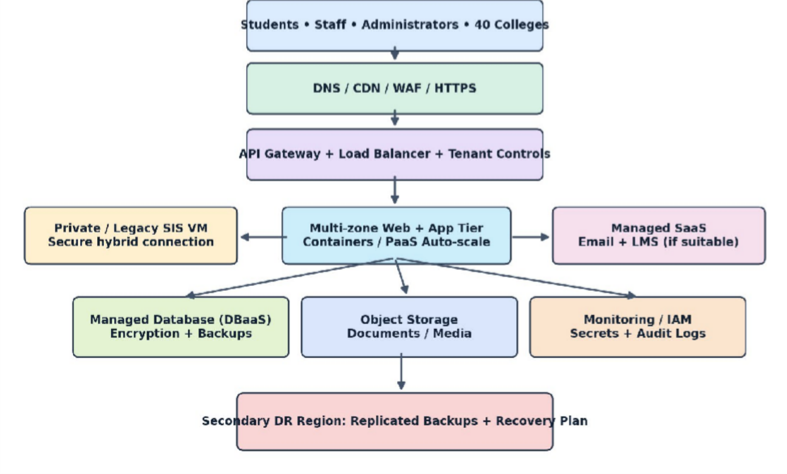
Figure 11.1: Modified hybrid architecture for mobile access, 40 affiliated colleges, 10× peak load and regional disaster recovery.
The revised design adds an API gateway with OAuth/OIDC-based identity, tenant-aware claims, per-college quotas, rate limits and audit logging. Stateless APIs run in orchestrated containers or a managed application platform with horizontal autoscaling across multiple availability zones. Read-heavy endpoints may use controlled caching, while asynchronous queues isolate non-immediate tasks. Payment initiation uses idempotency keys, server-side fee validation and verified payment-provider callbacks. Database access uses tenant-scoped queries or stronger separation where required by risk classification, with backups and tested restoration. The service model shifts more bursty web traffic to PaaS/serverless services, while legacy VMs remain only where necessary. DBaaS and DRaaS become higher-priority XaaS capabilities.

Capacity and Availability Defence:
Let measured baseline peak request rate be R requests/second. Revised peak demand is 10R. If a tested application instance can safely process C requests/second at the target latency, and the design uses a 70% load target, then the required active instances are N = ceiling(10R / (0.70 × C)). For an explicitly hypothetical example, R = 100 requests/second and C = 200 requests/second per instance,

so N = ceiling(1000/140) = 8 active instances. These are illustrative values only, not measured university performance. To tolerate a full-zone failure, additional capacity must be distributed across zones and verified with failure testing; eight instances alone do not prove resilience.
Availability of 99.9% allows 0.1% downtime: 365 × 24 × 0.001 = 8.76 hours per year, or 525.6 minutes. This is an end-to-end service objective, not simply a provider VM uptime claim. Monitoring, redundant application instances, database failover, tested recovery procedures and incident response must collectively support the target. Multi-region disaster recovery improves resilience, but recovery time and data-loss objectives require explicit testing.

Original Versus Revised Cost Illustration:
The Task 10 hybrid baseline is INR 47.2 lakh for three years under illustrative assumptions. A simple revised 10×-peak scenario adds INR 8.0 lakh for additional burst compute and API operations, INR
4.0 lakh for tenant security and monitoring, INR 3.0 lakh for database throughput and storage, and INR 2.0 lakh for expanded DR testing and recovery capacity. Revised illustrative three-year total =
47.2 + 8 + 4 + 3 + 2 = INR 64.2 lakh, an increase of INR 17.0 lakh (approximately 36.0%). The peak multiplier does not imply a tenfold bill because duration, caching and autoscaling determine actual resource consumption. All figures must be replaced with vendor quotes and measured usage.

Security, Trade-Offs and Final Defence:
Tenant isolation must be enforced at the API and data layers, never solely by a user-interface filter. College identity should be bound to authenticated tokens, with authorization checked for every student-record request and financial transaction. Database row-level policies or separate databases may be selected based on confidentiality requirements, cost and administrative overhead. Centralized logging should record tenant, actor, action and outcome without unnecessarily storing sensitive personal data. The modified solution improves scalability and resilience but introduces orchestration complexity, managed-service dependency and additional testing effort. These trade-offs are acceptable only if measured performance, privacy controls and the 99.9% availability objective can be validated within the approved budget.

Conclusion:
MODIFY is the justified decision because the original hybrid architecture provides a reusable foundation but lacks demonstrated 10× peak capacity and tenant-aware external integration. The revised design strengthens APIs, managed scaling, multi-zone deployment, tenant isolation, payment

reliability and disaster recovery. Capacity, availability and cost figures remain scenario-based estimates pending load tests, security tests and provider pricing validation.

